Supporting Information

Supplementary data

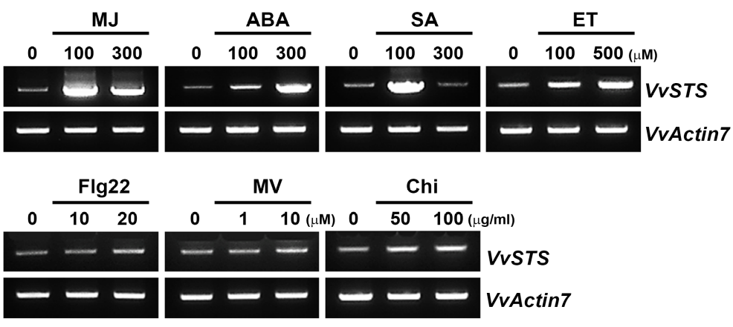
Fig. S1. Effect of various elicitors on the expression of the stilbene synthase gene (VvSTS) in grapevine cell suspension cultures. The cells were pre-cultured for 7 days and harvested 12 h after elicitation with different concentrations of elicitors for RT-PCR analysis. The elicitors used are as follows: MJ, methyl jasmonate; ABA, abscisic acid; SA, salicylic acid; ET, ethephon; Flg22, flagellin 22 peptide; MV, methyl viologen; Chi, chitosan. VvActin7 (XM_002282480.4) was used as a quantitative control.

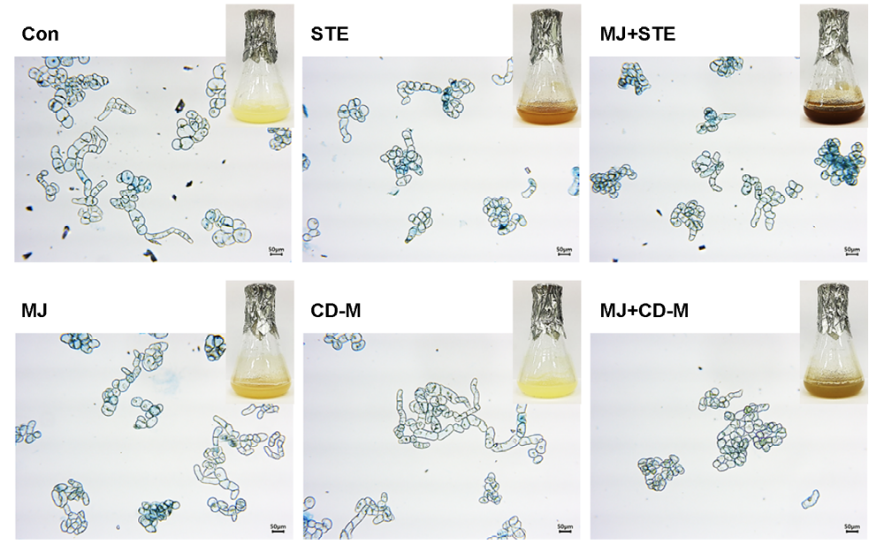
Fig. S2. Evans blue staining for cell viability 5 days after elicitation with different elicitors in flask culture of grapevine cells. Cell viability of grapevine cells after application of 100 μΜ MJ in combination with 50 mM CD-M or 50 mM STE was evaluated through 0.1% Evans blue staining. Scale bar indicates 50 µm.

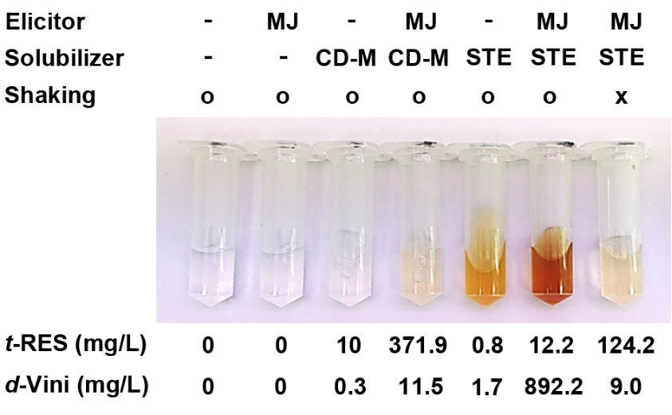
Fig. S3. Contents of trans-resveratrol and δ−viniferin produced in the culture medium in response to treatments with 100 μΜ MJ and 50 mM CD-M or 50 mM STE. Brown coloration indicates the presence of viniferin compounds.

Fig. S4. ¹H- and ¹³C-NMR spectra of δ−viniferin identified from grapevine cell cultures (A, B). trans-δ-Viniferin: ¹H NMR (500 MHz, Acetone-d₆) δ 7.45 (dd, J = 8.5, 2.0 Hz, H-6), 7.27 (s, H-4), 7.25 (d, J = 8.5 Hz, H-2,6A), 7.07 (d, J = 16.5 Hz, H-2′), 6.92 (d, J = 16.5 Hz, H-1′), 6.88 (d, J = 8.1 Hz, H-7), 6.86 (d, J = 8.5 Hz, H-3,5A), 6.55 (d, J = 2.0 Hz, H-2,6C), 6.29 (t, J = 2.0 Hz, H-2B), 6.27 (t, J = 2.0 Hz, H-4C), 6.21 (d, J = 2.0, H-4,6B), 5.47 (d, J = 8.0 Hz, H-2), 4.48 (d, J = 8.0 Hz, H-3); ¹³C NMR (125 MHz, Acetone-d₆) δ 159.7 (C-7a), 158.8 (C-1,3B), 158.6 (C-3,5C), 157.5 (C-4A), 144.3 (C-5B), 139.8 (C-1C), 131.6 (C-3a), 131.2 (C-1A), 130.8 (C-5), 128.2 (C-2′), 127.7 (C-6), 127.6 (C-2,6A), 126.3 (C-1′), 123.0 (C-4), 115.2 (C-3,5A), 109.2 (C-7), 106.4 (C-4,6B), 104.7 (C-2,6C), 101.8 (C-4C), 101.4 (C-2B), 93.1 (C-2), 56.9 (C-3).

